**Hands On Steps:**

1. To create a React Application with the name of “sourav_react”,type the following command:

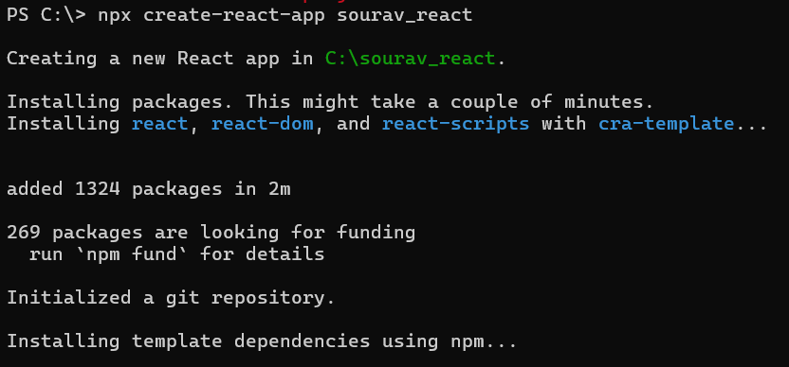

1. Go to sourav_react/src/App.js:

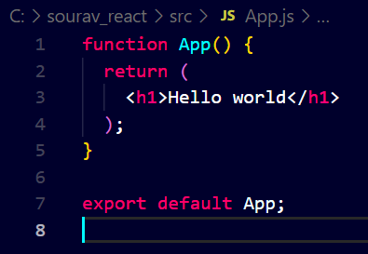

1. Start the App:

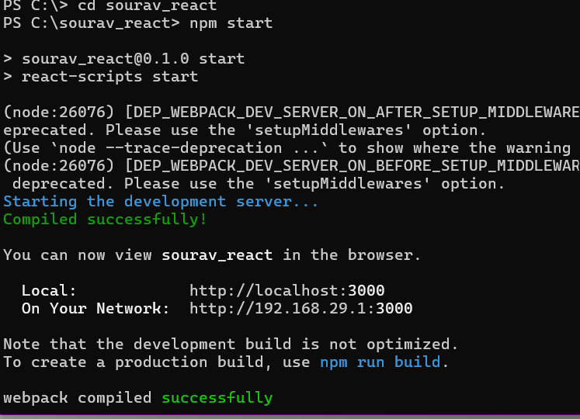

1. Open a new browser window and type “localhost:3000” in the address bar

